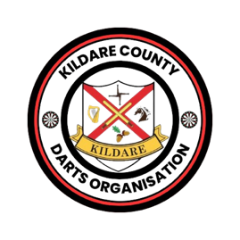
KILDARE COUNTY DARTS ORGANISATION
CODE OF CONDUCT
Players:
Players shall always behave in a proper and correct manner consistent with their status as a county thrower.
Players shall not do anything which is likely to intimidate, offend, insult, humiliate or discriminate against any other person on the grounds of disability, religion, race, colour or national or ethnic origin, sex, or sexual orientation.
Be respectful and to all players.
Avoid using offensive, hateful or harassing language.
Social media communication:
Communication is an integral part of our organisation. We will be sharing up to date information on our Facebook and WhatsApp groups.
Whilst we encourage active participation on our social medias any comments or posts shall not offend, intimidate, humiliate, bully another person or persons or bring the organisation into disrepute.
Do not post or share material which is violent, sexually explicit, obscene, hateful or defamatory.
Always respect the counties values.
I.N.D.O & K.C.D.O Events:
Each player shall participate in all darts events in a fair and sporting manner and shall co-operate with all event officials.
Players must comply with the entry terms and conditions of each darts event that they enter.
All players and guests will desist from any behaviour that may be construed as gamesmanship before, during or after any darts event.
Invited guests at any darts event are the responsibility of the respective player who may be held accountable for their guest’s behaviour.
Any player or official who is taking part in a darts event and are disruptive to the running of the darts event maybe asked to leave the premises.
Players must not recklessly throw their darts at any time.
All competing players in team events must be in the venue at least 60 minutes before the start of their first match.
These events are normally 2-day events so any player who doesn’t turn up for the 2nd day may face disciplinary action if without a valid reason.
If a player who has qualified for the county panel knows they cannot compete at any given event they need to contact one of the committee members.
Disputes & Disciplinary:
Failure to abide by the code of conduct set out above may lead to sanctions.to be determined by the Committee. Such sanctions may range from temporary or permanent removal from social media groups and may lead to expulsion.

Kildare county Darts may from time-to-time supplement, amend or vary these rules. All players will be informed of any such changes.

